# PROJECT TITLE

**DEEP LEARNING FUNDUS IMAGE ANALYSIS FOR EARLY DETECTION OF DIABETIC RETINOPATHY USING IBM WATSON**

Submitted to the Faculty of Engineering of

**JAWAHARLAL NEHRU TECHNOLOGICAL UNIVERSITY KAKINADA,**

**KAKINADA**

In partial fulfillment of the requirements for the award of the Degree of

**BACHELOR OF TECHNOLOGY**

In

**COMPUTER SCIENCE AND ENGINEERING**

By

**Student Name(Roll No.)**

**G.Nikhila(19481A0560) B.Lalitha Sri(19481A0531)**

**B.Satya Rahul(19481A0513) B.Sneha(19481A0525)**

Under the Enviable and Esteemed Guidance of

**Mr/Mrs. Name of the Faculty, Qualification**

Designation of Faculty, Department of CSE

M.N.Satish Kumar, M.Tech



**DEPARTMENT OF COMPUTER SCIENCE AND ENGINEERING**

**SESHADRI RAO GUDLAVALLERU ENGINEERING COLLEGE**

**(An Autonomous Institute with Permanent Affiliation to JNTUK, Kakinada)**

**SESHADRIRAO KNOWLEDGE VILLAGE**

**GUDLAVALLERU – 521356**

**ANDHRA PRADESH**

**2022-23**

**SESHADRI RAO**

**GUDLAVALLERU ENGINEERING COLLEGE**

**(An Autonomous Institute with Permanent Affiliation to JNTUK, Kakinada)**

**SESHADRI RAO KNOWLEDGE VILLAGE, GUDLAVALLERU**

**DEPARTMENT OF COMPUTER SCIENCE AND ENGINEERING**



**CERTIFICATE**

This is to certify that the project report entitled **“Project Title”** is a bonafide record of work carried out by **G.Nikhila Sai(19481A0560),B.Lalitha Sri(19481A0531), B.Satya Rahul(19481A0513), B.Sneha (19481A0525)** under the guidance and supervision of **M.N.Satish Kumar** in the partial fulfillment of the requirements for the award of the degree of **Bachelor of Technology in Computer Science and Engineering of Jawaharlal Nehru Technological University Kakinada, Kakinada** during the academic year 2022-23.

**Project Guide Head of the Department (M.N.Satish Kumar) (Dr. M. Babu Rao)**

**External Examiner**

**ACKNOWLEDGEMENT**

The satisfaction that accompanies the successful completion of any task would be incomplete without the mention of people who made it possible and whose constant guidance and encouragements crown all the efforts with success.

We would like to express our deep sense of gratitude and sincere thanks to

**M.N.Satish Kumar, M.Tech,** Department of Computer Science and Engineering for **his** constant guidance, supervision and motivation in completing the project work.

We feel elated to express our floral gratitude and sincere thanks to **Dr. M. Babu Rao** , Head of the Department, Computer Science and Engineering for his encouragements all the way during analysis of the project. His annotations, insinuations and criticisms are the key behind the successful completion of the project work.

We would like to take this opportunity to thank our beloved principal **Dr.G.V.S.N.R.V. Prasad** for providing a great support for us in completing our project and giving us the opportunity for doing project.

Our Special thanks to the faculty of our department and programmers of our computer lab. Finally, we thank our family members, non-teaching staff and our friends, who had directly or indirectly helped and supported us in completing our project in time.

**Team members**

**G.Nikhila Sai(19481A0560)**

**B.LalithaSri(19481A0531)**

**B.Satya Rahul(19481A0513)**

**B.Sneha(19481A0525)**



**INTERNSHIP REPORT APPROVAL FORM**

Date

With immense pleasure, this is to approve that the students of Seshadri Rao Gudlavalleru Engineering College i.,e G.Nikhila Sai(19481A0560), B.Lalitha Sri(19481A0531), B.Satya Rahul(19481A0513), B.Sneha (19481A0525) successfully completed their Project and Project Report on **“DEEP LEARNING FUNDUS IMAGE ANALYSIS FOR EARLY DETECTION OF DIABETIC RETINOPATHY USING IBM WATSON”** under our guidance.

We are highly impressed with the work that they have done and commend them on their quick grasping skills. They have shown good intent to learn and have put the knowledge gained into application in the form of this project. We appreciate the hard work and commitment shown by them.

We, hereby approve that this document is completely checked and accepted by SmartBridge Technical Team. Its been an absolute pleasure to educate and mentor these students. We hope that this document will also serve as a Letter of Recommendation, to whomsover applied.

We wish them success in all future endeavors and a great career ahead.

**Name and Designation of smart bridge mentor**

**INDEX**

**TITLE PAGENO**

**CHAPTER 1: INTRODUCTION**

* 1. OVERVIEW
  2. PURPOSE

**CHAPTER 2: LITERATURE REVIEW**

2.1 EXISTING PROBLEM

2.2 PROPOSED SOLUTION

**CHAPTER 3: THEORITICAL ANALYSIS**

* 1. BLOCK DIAGRAM
  2. HARDWARE/SOFTWARE DESIGNING

**CHAPTER 4: RESULTS AND DISCUSSSION**

1. EXPERIMENTAL INVESTIGATIONS
2. FLOWCHART
3. RESULT
4. ADVANTAGES AND DISADVANTAGES
5. APPLICATIONS
6. CONCLUSION
7. FUTURE SCOPE

**REFERENCES**

**DEEP LEARNING FUNDUS IMAGE ANALYSIS FOR EARLY DETECTION OF DIABETIC RETINOPATHY**

**USING IBM WATSON**

1. **INTRODUCTION**

1.1 OVERVIEW:

Diabetic Retinopathy (DR) is a common complication of diabetes mellitus, which causes lesions on the retina that affect vision. If it is not detected early, it can lead to blindness. Unfortunately, DR is not a reversible process, and treatment only sustains vision. DR early detection and treatment can significantly reduce the risk of vision loss. The manual diagnosis process of DR retina fundus images by ophthalmologists is time, effort and cost-consuming and prone to misdiagnosis unlike computer-aided diagnosis systems. Transfer learning has become one of the most common techniques that has achieved better performance in many areas, especially in medical image analysis and classification. We used Transfer Learning techniques like Inception V3, Resnet50, Xception V3 that are more widely used as a transfer learning method in medical image analysis and are highly effective.

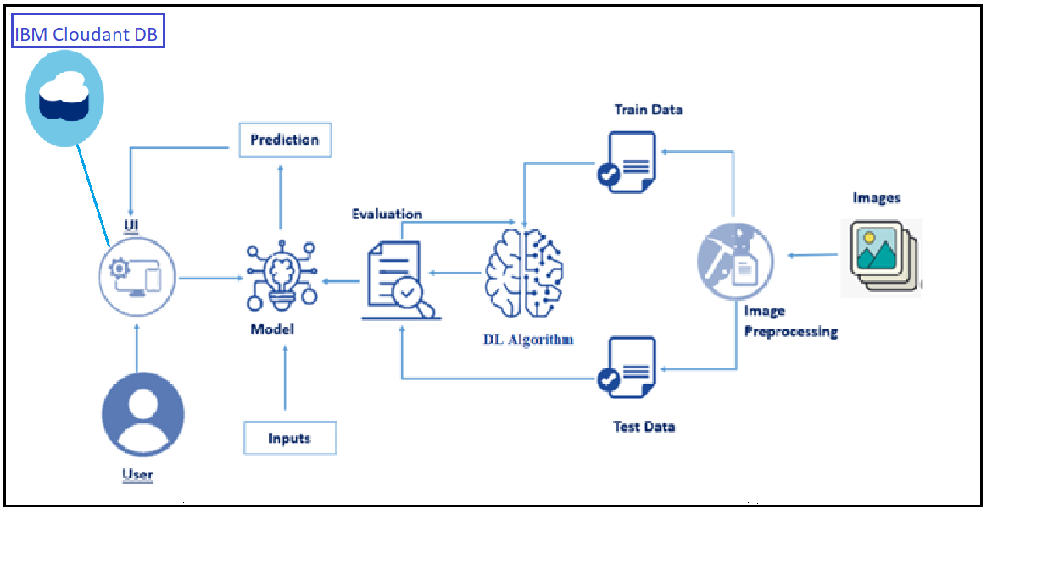

* 1. PURPOSE
* The primary aim of this project is to develop a system that will be able to identify patients with BDR and PDR from either colour image or grey level image obtained from the retina of the patient.
* The computer-aided diagnosis is to recognize DR and normal images in utilizing features like veins, diameter, colour and so on.
* Identification of the distinctive shape of abnormal retinal pictures through reconstruction methods and edge detection leads to the conclusion of DR.

1. **LITERATURE SURVEY** 
   1. EXISTING PROBLEM

The existing methodology includes pre-processing of retinal images, consisting of size adequacy, data cleaning (the removal of low-quality images from other classes and inclusion of them in class 5), data augmentation and class balancing during the training phase, and hyperparameter adjustment and image classification using the VGG16 neural network.

* DRAWBACKS
* Heavier model
* More training time
* Vanishing gradient problem

* 1. PROPOSED SOLUTION

Xception is a convolutional neural network that is 71 layers deep. You can load a pretrained version of the network trained on more than a million images from the ImageNet database . The pretrained network can classify images into 1000 object categories, such as keyboard, mouse, pencil, and many animals. As a result, the network has learned rich feature representations for a wide range of images. The network has an image input size of 299-by-299.

1. **THEORITICAL ANALYSIS**
   1. BLOCK DIAGRAM

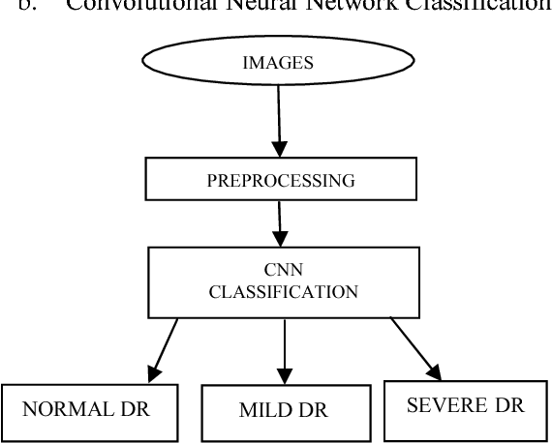

* 1. HARDWARE/SOFTWARE DESIGNING
* Hardware Requirements
* Processor-i5
* RAM-8GB
* Software requirements
* Anaconda3
* Jupyter Notebook
* Brackets
* Spyder

1. **EXPERIMENTAL INVESTIGATIONS**

For the purpose of selecting the most suitable prediction model for Diabetic Retinopathy detection this paper uses the comparative experimental method. Specific concrete samples are prepared in the laboratory, and the data are preprocessed after understanding the characteristics of each data, so as to select the model with the best prediction performance based on machine learning theory.

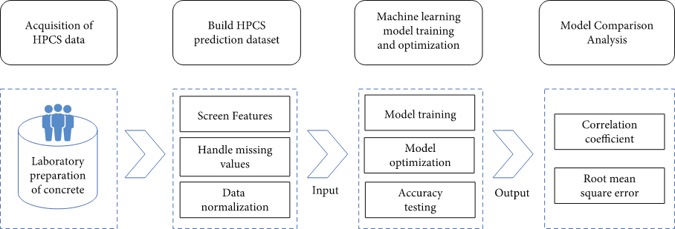

**5 FLOWCHART**

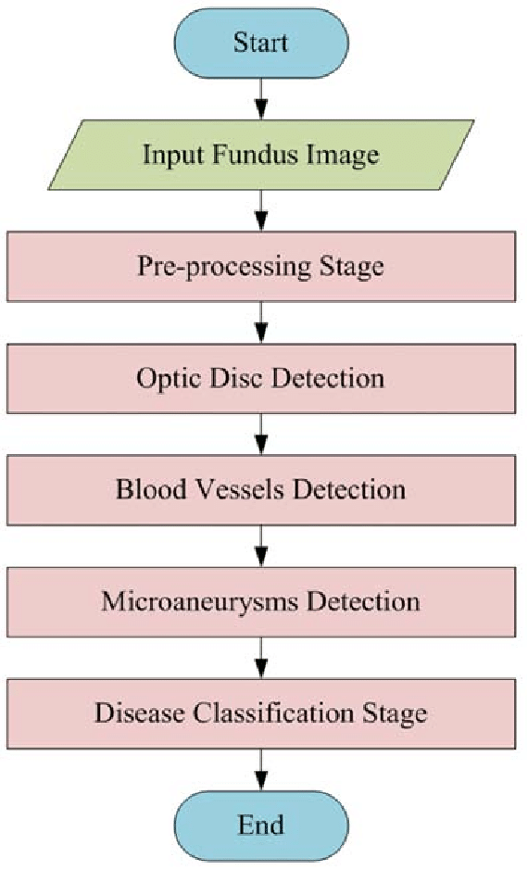

**6 RESULT**

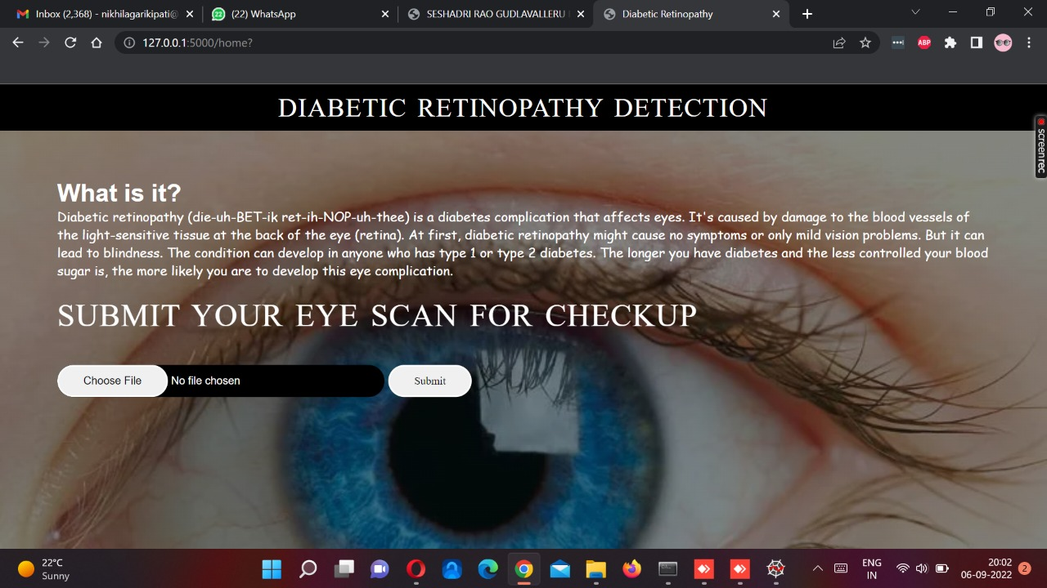

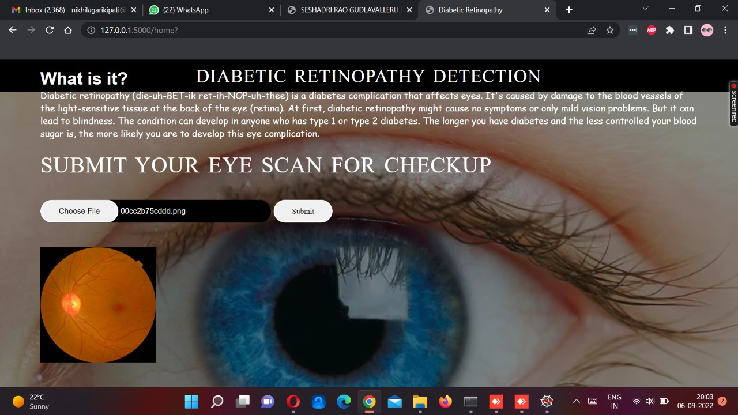

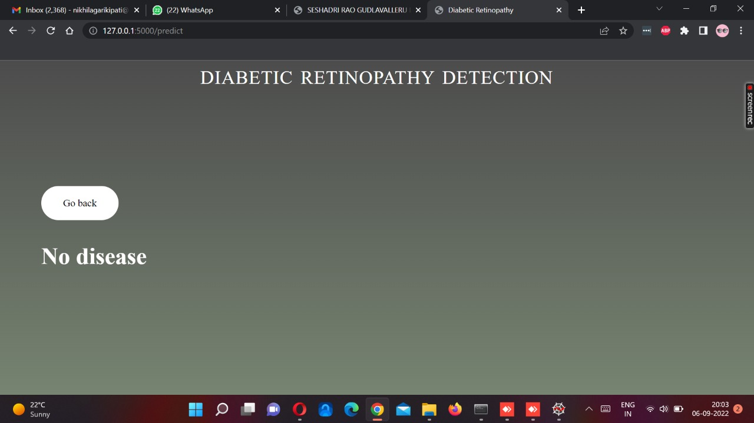

**7 ADVANTAGES & DISADVANTAGES**

* Advantages
* The low contrast retinal image-intensity increased and a number of edge pixels were extracted.
* Disadvantages
* More time consuming.

**8 APPLICATIONS**

* Real-time image quality assessment
* Lesion detection
* Grading

**9 CONCLUSION**

The paper is about proposing an optimal model for Diabetic Retinopathy detection. Processing of Retinopathy images is very essential to get proper features. Statistical values can predict level of severity properly but in case of noisy images the chances of getting poor data will lead to lower accuracy. For getting better result selecting for proper features out of the image also important. CNN model is effective in term for image, because of CPU training time of CNN getting affected in the study, in this case CNN is used for training accuracy as well as validation accuracy. For future work model can train with GPU system, with more number of processed data for getting higher accuracy result.A standalone application will be good for identification of retinopathy images.

**10 FUTURE SCOPE**

For future work model can train with system, with more number of processed data for getting higher accuracy result Diabetic retinopathy remains a major cause of visual impairment and blindness, just as diabetic nephropathy is a major cause of renal failure, owing to the growing burden of type 2 diabetes. Over one-third of the worlds 285 million people with diabetes are estimated to have diabetic retinopathy, and one-third of these (approximately 3.2 million) have vision-threatening retinopathy. Nowadays, image processing techniques with deep learning have performed a vital role in computer-aided systems to diagnose abnormalities in diabetic retinopathy. There are some possible directions that may help to fully utilize the deep learning approaches in a more effective way. In the literature, it was noted that most research work has been performed with the use of convolutional neural network models to develop deep multi-layer frameworks for the diagnosis of diabetic retinopathy using digital retinal fundus images, but on the other hand, the analysis and explanation of retinal photographs need ophthalmologists, which is time-consuming and very expensive task. The risk of vision loss from diabetic retinopathy has fallen dramatically over the past 3 decades with improvements in diabeties and blood pressure treatments, and with advances in laser surgery and intraocular drug delivery. Nevertheless, diabetes remains to be a major cause of blindness. This paper summarizes the state of the art in diabetic retinopathy research and provides a perspective on opportunities for future investigations.

**REFERENCES**

* <https://ieeexplore.ieee.org/abstract/document/9277506>
* <https://www.sciencedirect.com/science/article/pii/S2352914820302069>
* <https://www.youtube.com/watch?v=5HxVsp8Wzgo>
* <https://www.youtube.com/watch?v=uN0tKs1xGl4>